4.Design and Configuration of RING Topologies using Packet Tracer

Ring Topology using Hub:

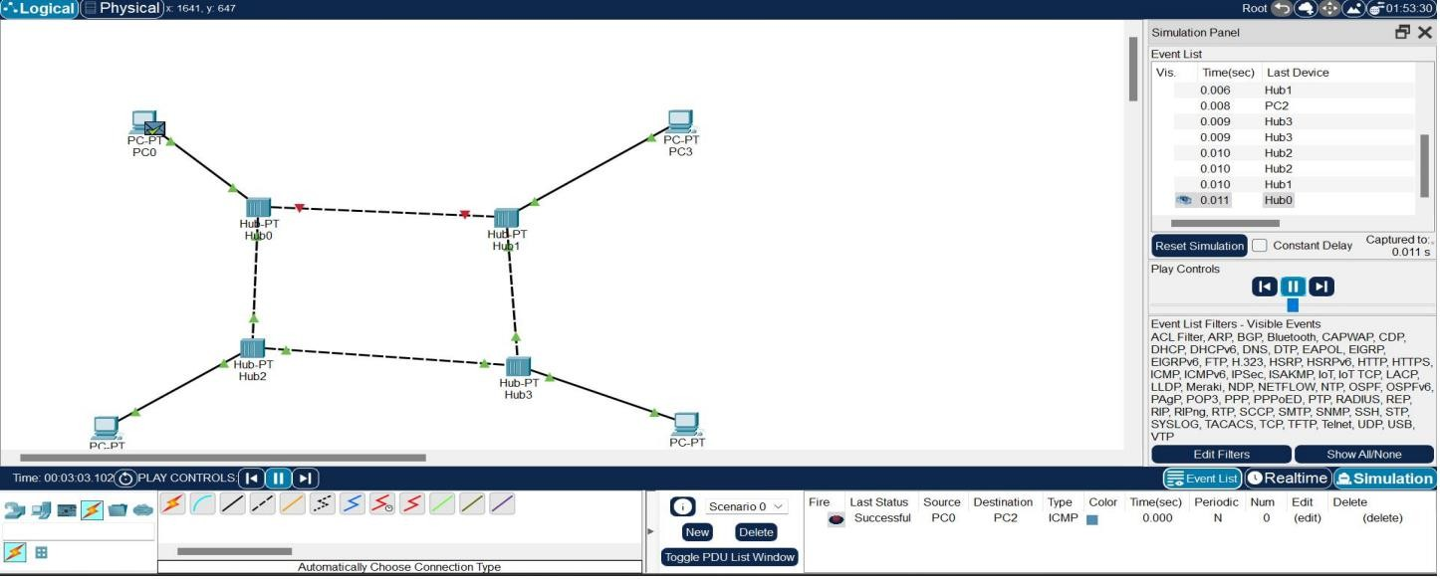

Ring Topology using Switch:

